MINISTRY OF EDUCATION AND SCIENCE

OF RUSSIAN FEDERATION

Federal State Budgetary Educational Institution of Higher Education

**«Kuban State University»**

**Faculty of Economics**

The Department of Marketing and Trade

**C O U R S E W O R K**

**Theme:** Econometric modelling of Augmented Reality effectiveness as a marketing tool

Student

Direction of preparation

Scientific leader

Krasnodar 2019

Contents

Introduction…………………………………………………………………………...3

1st Chapter: Theory of the Multiple Regression Analysis with Cross-Sectional data……………………………………………………………………………………5

* 1. Definitions and tasks of the Multiple Regression Analysis……………………5
  2. The methods of the Multiple Regression Analysis…………………………….9
  3. Methodology of the econometric modelling and forecasting using Multiple Regression Analysis…………………………………………………………..13

2nd Chapter: Analysis of the Augmented Reality impact on Digital Marketing…….16

2.1 The state of the Digital Marketing……………………………………………….16

2.2 The analysis of the Augmented Reality application in Digital Marketing…….…20

2.3 The factors affecting the application of Augmented Reality in Digital Marketing………………………………………………………………….…………22

3rd Chapter: Econometric Modelling and Forecasting of Augmented Reality effectiveness as a marketing tool…………………………………………………….24

3.1 Panel Data Set for Augmented Reality effectiveness Multiple Regression Analysis………………………………………………………………………………24

3.2 Algorithms of the Econometric Modelling Process using Multiple Regression Analysis of Augmented Reality effectiveness as a marketing tool…………………..27

3.3 Forecasting of the future impact of Augmented Reality efficiency as a marketing tool……………………………………………………………………………………30

Conclusion…………………………………………………………………………....33

List of Literature……………………………………………………………………...34

APPENDIX 1………………………………………………………………………...37

INTRODUCTION

The following paper covers the state of Digital marketing in Russia and the world nowadays and is focused on the popularity of Artificial Reality (AR) technology on the market of Russia.

The relevance of the topic is justified by the tremendous speed and development of Digital Marketing in the world and the need to research new ways of delivering information and content to consumers. It is also important to gather data on the overall technological awareness of the Russian population, as to observe the level of technological literacy and readiness of the Market in Russia.

The goal of this paper is to trace the correlation between various factors of technological lifestyle, awareness about the AR and the readiness to use products containing it.

The method of econometric modelling and Multiple Regression was the primary in this paper. The qualitative method of questionnaire was used in order to gather data.

The researcher had a following set of tasks:

-to study academic literature on Multiple regression

-to make an overview and study the main aspects about the state of AR in the world

- To draw a distinction between AR and VR, and explain the technology

- To describe how AR is currently used in the world, from the marketing standpoint

-to gather statistical data by carrying out a questionnaire

- to prepare data for the econometric modelling

- to build an econometric model of the data provided, by using specific methods

The object of the research is Digital Marketing and the use of AR in it.

The subject of the research is the econometric modelling of AR’s popularity among Russian citizens, based on the questionnaire data.

The following results have immediate value, as they show the current market condition in respect to AR. This may help aspiring start-up businesses make decisions on product launches in certain areas in Russia.

The theoretical foundation of the paper comprises works on econometric modelling by such acclaimed researchers as Wooldridge, Greene, Weisberg, Greene and others, as well as leading Marketing specialists such as Kotler, Chaffey, Merel and others.

1st Chapter: Theory of the Multiple Regression Analysis with Cross-Sectional data.

* 1. Definitions and tasks of the Multiple Regression Analysis.

Statistical data analysis is used in a wide variety of branches of human activity. It is difficult to find a sphere in which statistical processing is not used. But it is worth noting that no one area of ​​research statistical data plays such an exceptionally important role as in the economy. It is in this industry that we deal with processing and analysis of vast amounts of information on socio-economic phenomena and processes. A comprehensive and in-depth analysis of this information, called statistical data, involves the use of various special methods, an important place among which is occupied by the correlation and regression analyses of processing statistical data [2, p. 9].

In statistical modelling, regression analysis is a study used to assess the relationship between variables. This mathematical method includes many other methods for modelling and analysing several variables, with the main focus on the relationship between the dependent variable and one or more independent ones. More specifically, regression analysis helps to understand how the typical value of the dependent variable changes if one of the independent variables changes, while the other independent variables remain fixed [8, p.12].

The main tasks of econometrics include:

* Construction of econometric models, i.e. representation of economic models in mathematical form, which is convenient for empirical analysis.
* Evaluation of the parameters of the constructed model, making the selected model the most adequate to real data.

- Checking the quality of the found parameters of the model and the model itself as a whole.

- Using the constructed models to explain the behavior of the studied economic indicators, forecasting and predictions, as well as for meaningful economic policy.

Thus, the standard dependency analysis scheme consists in implementing a number of consecutive procedures [27, p. 34]:

- Selection of the initial model (specification stage). It is based on economic theory, previous knowledge about the object of study, experience the researcher and his intuition.

- Estimation of model parameters based on available statistical data (stage parameterization).

- Implementation of model quality control (verification phase).

- If there is at least one unsatisfactory answer by any criterion the model is being improved to eliminate the identified deficiency.

- With positive answers for all criteria, the model is considered to be qualitative. It is used to analyze and forecast the explained variable.

There are several distinctive features of a successful model [8, p.25]:

* The model should be as simple as possible. This property is determined by the fact that the model does not reflect reality perfectly, but is a simplification.
* For any set of statistics the defined coefficients must be calculated unambiguously.
* Maximum compliance. The equation is the better, the greater part of the spread dependent variable it can explain.
* Consistency with theory. No equation can be recognized. quality, if it does not meet the known theoretical assumptions. In other words, the model must necessarily be based on a theoretical foundation, otherwise, the result of using the regression equation may be very pitiable.
* Expected quality. The model can be recognized as high-quality, if received values are confirmed by reality.

Within the framework of econometric analysis, the main task is usually to determine a certain quantity (indicator), the value of which is formed under the influence of certain factors. Indicators, such as price, are usually called dependent (explained) variables, and the factors on which they depend are independent variables (explanatory factors) [29, p. 32]. We are usually interested in the mean or expected value of the dependent variable for given values of explanatory variables. The specific value of the dependent variable (the observed value) usually depends on random events. For economics, such a form of connection between variables is typical, when each value of one variable corresponds not to some specific value of another variable, but to a set of possible values ​​(more precisely, some conditional distribution) to another variable. Such dependence is called statistical (stochastic, probabilistic) [29, p.26]. The stochastic form of communication occurs, due to the fact that the dependent variable is influenced by a number of uncontrolled or unrecorded factors, as well as the fact that the measurement of the variable values ​ is usually accompanied by some random errors.

It is very important to realize the specifics of measurements when building econometric models. The economy is referred to as "inaccurate" science, since it is impossible to produce measurement without error [21, p. 17]. The task of determining the experimental error is far from simple. Main difficulty lies in the fact that it is necessary to take into account various factors that affect the result. In any particular experiment, it is impossible to analyze or even specify all factors affecting the result. Therefore, the true value of the error remains unknown, one can only try to provide the most accurate estimate of the error. The degree of reliability of this assessment depends primarily on how in this particular experiment factors influencing the result of measurement or modeling are taken into account. In econometrics, there are two error categories [21, p. 23]. The first ones are the so-called systematic errors.

Systematic errors, that cause the final result shifting to one or another direction. They are practically unchanged for the time of experience and are included in the final result unaltered. Sources of systematic errors can be: instrumental errors (malfunctions of the measuring equipment); errors related to the state of the environment in which measurements are produced; individual errors (subjective or personal errors); errors introduced by the chosen method of the research. Since systematic errors are determined by the method of the experiment, then no general theory of these errors can exist. However, if the source of the systematic error is known, then its influence on the result can be taken into account [21, p.35].

The second category includes random errors. Random errors are attributed to factors, which are subject to minor changes. Since the outcome of each individual observation depends on the actions of a large number of different factors, the result depends on a random variable. Consequently, the experimental error caused by the these variables (factors) is also random. I this case, an error is treated as a quantity controlled by laws of probability. Random error is sometimes also called statistical error.

When modeling economic processes the following data types may be used [6, p. 45]:

- Cross-sectional data, which is information on different objects, taken at same period or point in time. For example, a set of information on different firms (production, number of employees, size of production assets, etc.).

- Time Series data, which is a set of information characterizing the same object, but for different periods or times. For example, quarterly data on average wages, consumer price index, number of people employed in recent years.

- Panel (or Longitudinal) data, which is a time series for eachcross-sectional  
member in the data set.

The following types of variables [8, p. 21] can be involved in the econometric model:

* exogenous (independent) variables, the values ​​of which are set from the outside, autonomously, and which are manageable (planned). In short, these are X-variables;
* endogenous (dependent) variables, whose values ​​are determined within the model, or the Y-variables;
* lagged variables are exogenous or endogenous variables of the econometric model, dated by previous times and in equation with current variables. For example: yt is the current endogenous variable, yt-1 is a lagged

endogenous variable;

* Predefined variables (explaining variables). These variables include lagged and current exogenous variables (xt, xt-1), as well as lagged endogenous variables (yt-1).

Any econometric model is intended to explain the values ​​of current endogenous variables (one or more) depending on the values of predefined variables [6, p. 23].

When talking about interdependencies in the economy, we cannot name functional, or strict, dependencies. Instead, we use the term correlation. The correlation dependence occurs when one quantitative value changes the mean of the other [2, p. 31].

* 1. The methods of the Multiple Regression Analysis.

Currently, multiple regression is one of the most common methods in econometrics. The main goal of multiple regression is to build a model with a large number of factors, as well as to determine the influence of each factor individually and their cumulative impact on the simulated indicator.

Multiple regression analysis is the development of simple regression analysis in cases where the dependent variable is associated with more than one independent variable. Much of the analysis is an immediate extension of the paired regression model, but here too there are some new problems, two of which should be highlighted. The first problem concerns the study of the influence of a specific independent variable on a dependent variable, as well as the distinction between its effects and the effects of other independent variables. The second important problem is the specification of the model, which consists in answering the question of which factors should be included in the regression and which should be excluded from it [7, p. 52].

Multiple regression analysis is a method of establishing the dependence of one variable on two or more independent variables. While the dependent variable must be continuous, independent variables can be either discontinuous or categorical. In the case of categorical independent variables, it will be necessary to create dummy variables instead of using the corresponding values. If all independent variables are categorical (or most of them are categorical), then it is better to use analysis of variance [9, p. 55].

There are two reasons for using multiple regression. The first is the use of multiple regression in those studies when the values ​​of independent variables were under experimental control. The second option includes situations when a group of patients is analyzed in which they measured some of the number of naturally occurring variables (age, income, anxiety level, etc.), and these variables are associated with some variable that interests the researcher [23, p. 41].

The most common of the multiple regression models is the linear model of multiple regression:

$y=a^{'}+β_{1}^{'x_{1}}+β_{2}x_{2}+…+β_{k}'x_{k}+ε$ (1)

The parameter α is called the free term and determines the value of *y* in the case when all explanatory variables are zero [29, p. 61]. However, as in the case of pair regression, the factors in their economic content often cannot take on zero values, and the value of a free member does not have an economic sense. At the same time, in contrast to the pair regression, the value of each regression coefficient is equal to the average change in *y* with increasing $x_{i}$ by one unit only under the condition that all other factors remain unchanged. The value of ε is the random error.

At the same time, it is most simply possible to determine the parameter estimates by changing only one factor $x_{i}$, while keeping the values ​​of other factors unchanged. Then the task of estimating the parameters would be reduced to a sequence of tasks of paired regression analysis for each factor. However, this approach, is unacceptable in economics [28, p. 34]. The economist is deprived of the opportunity to regulate certain factors, since it is not possible to ensure equality of all other conditions for assessing the influence of one factor being studied.

Obtaining estimates of the parameters of the regression equation is one of the most important tasks of multiple regression analysis. The most common method of solving this problem is the method of least squares (OLS). Its essence consists in minimizing the sum of the squares of the deviations of the observed values ​​of the dependent variable y from its values, obtained from the regression equation [29, p. 67]. Since the parameters are random variables, it is impossible to determine their true values ​​from the sample. Therefore, instead of the theoretical regression equation, the so-called empirical regression equation is estimated, which can be represented as:

$y=a+b_{1}x_{1}+b_{2}x_{2}+…+b_{k}x_{k}+e$ (2)

Here $b_{1}, b_{2}, b_{k}, a$ are the estimates of theoretical values, or empirical regression coefficients, and e is the estimate of the deviation ε. Then the calculated expression has the form:

$\hat{y}=a+b_{1}x_{1}+b_{2}x_{2}+…+b_{k}x_{k}$ (3)

To carry out the analysis within the framework of the linear model of multiple regression, it is necessary to fulfil a number of prerequisites of OLS. Basically, these are the same prerequisites as for simple regression, but here we need to add assumptions specific to multiple regression [28, p.64]:

- The model specification has the form.

- The absence of multicollinearity: there is no strict linear relationship between the explanatory variables, which plays an important role in the selection of factors in solving the problem of model specification.

- Errors have a normal distribution.

To check the overall quality of the regression equation, the coefficient of determination R2 is used [21, p.62], which is generally calculated by the formula:

$R^{2}=1-\frac{\sum{e_{i}^{2}}}{\sum{{\left(y_{i}-\overline{y}\right)}^{2}}}$ (4)

Its values ​​are between zero and one. The closer this coefficient is to unity, the more the regression equation explains the behavior of *y*. For multiple regression, R2 is a non-decreasing function of the number of explanatory variables. Adding a new explanatory variable never reduces the value of R2. Indeed, each of the following explanatory variables can only supplement, but in no way reduce, the information explaining the behavior of the dependent variable [9, p. 71].

Analysis of the statistical significance of the coefficient of determination is carried out by testing zero hypothesis H0: R2 = 0 versus alternative hypothesis H1: R2> 0. To test this hypothesis, we use the following F-statistics [8]:

$F=\frac{R^{2}}{1-R^{2}}*\frac{n-p-1}{p}$ (5)

If F = 0, then R2 = 0, and the regression line is best in OLS, and, therefore, *y* is linearly independent. To test the null hypotheses at a given level of significance α on the tables of critical points of the Fisher distribution, the critical value of F is found (α; p; n-p-1). If F> F­t, the zero hypothesis is rejected.

In addition to the coefficient of determination R2, in the equation of the multiple regression, another indicator is used that is closely related to R2. This is the so-called multiple correlation indicator [6], equal to the square root of R2:

(6)

The boundaries of its change are the same as in the pair regression: from 0 to 1. The closer its value is to one, the closer is the connection of the resultant trait with the entire set of factors studied.

* 1. Methodology of the econometric modelling and forecasting using Multiple Regression Analysis.

All previous reasoning and conclusions concerning classical multiple regression were based on the assumption that we are dealing with the correct specification of the model. In this case, the model specification is understood as the choice of explanatory variables. In this regard, it is important to consider two issues that make sense in multiple regression, when a researcher deals with several factors: possible multicollinearity of factors and partial correlation. The latter is especially closely related to the procedures for the step-by-step selection of variables [29].

The inclusion of a set of factors into the multiple regression equation is primarily due to the researcher’s understanding of the nature of the relationship between the modeled indicator and other economic phenomena. The factors included in the multiple regression should meet the following requirements [6]:

1. They must be quantifiable. If it is necessary to include in the model a qualitative factor that does not have a quantitative measurement, then it needs to be quantified.

2. Factors should not be correlated with each other and even more so in an exact functional relationship. Inclusion in the model of factors with a high mutual correlation can be ill-conditioned and lead to instability and unreliability of estimates of the regression coefficients. So, it is assumed that the factors x1 and x2 are independent. Then we can say that the parameter b1 measures the strength of the influence of the factor x1 on the result y with a constant value of the factor x2. With a change in the factor x1, the factor x2 cannot remain unchanged [6].

As mentioned earlier, the addition of a new factor in regression leads to an increase in the coefficient of determination and a decrease in the residual dispersion. However, these changes may be minor.

Thus, although theoretically the regression model allows to take into account any number of factors, practically this is not necessary. The selection of factors is made on the basis of qualitative theoretical and economic analysis. However, a theoretical analysis often does not allow an unambiguous answer to the question of the quantitative relationship between the considered features and the expediency of the inclusion of a factor in a model. Therefore, the selection of factors is usually carried out in two stages: at the first, factors are selected based on the nature of the problem; on the second, a matrix of correlation indicators is analyzed and it is determined which of the factors are most closely related to the result, and which factors are most closely related to each other [2].

Here the econometrician most often faces the problem of multicollinearity.

By full multicollinearity is understood to be the existence of some of the factors of a linear functional relationship between them [21].

The following are the main consequences of multicollinearity:

1. Large variance estimates. This makes it difficult to find the true values ​​of the determined values ​​and extends the interval estimates, worsening their accuracy.

2. The t-statistics of the coefficients decrease, which may lead to an unjustified conclusion that the effect of the corresponding factor on the dependent variable is irrelevant.

3. Estimates of the OLS coefficients and their standard errors become very sensitive to the slightest changes in the data, i.e. they become unstable.

4. It is difficult to determine the contribution of each of the explanatory variables to the variance of the dependent variable explained by the regression equation.

5. It is possible to get the wrong sign for the regression coefficient.

There is no single approach to the elimination of multicollinearity. There are a number of methods that are not universal and are applicable in specific situations [6].

The simplest method for eliminating multicollinearity is to exclude one or several correlated variables from the model. Here care must be taken not to drop the variable that is necessary in the model in its economic essence, but often correlates with other variables (for example, the price of the good and the price of substitutes for the good).

Sometimes, to eliminate multicollinearity, it is enough to increase the sample size. For example, using annual data, you can go to quarterly data. This will lead to a reduction in the dispersion of the regression coefficients and an increase in their statistical significance. However, it is possible to strengthen the autocorrelation, which limits the possibilities of such an approach.

In addition to models containing only quantitative variables, regression analysis also considers models containing only qualitative variables, or both. Regression models containing only qualitative explanatory variables are called ANOVA - models (analysis of variance models) [29].

2nd Chapter: Analysis of the Augmented Reality impact on Digital Marketing

2.1 The state of the Digital Marketing.

The new information environment in the publications of F.Kotler and G.Armstrong is becoming one of the most important in line with personal sales, targeted mailings and telemarketing [12]. Immersion in science and practice for most researchers of that period is becoming one of the key points for studying the globalization of the Internet. The growth of interest in e-commerce and heightened attention to the field of commerce contributed to the further development of ideas about the role of Internet technologies in the operational activities of organizations. The preparation of marketing plans for enterprises and development plans in the Internet environment has become divided among many economic actors. This process has led to the creation of a whole direction for working with the new information environment, which includes the adaptation of the skills of employees to work with databases and Internet technologies; organization of information management to optimize and improve the efficiency of the enterprise; systematization of actual software tools used to solve marketing problems.

Gradually with the growth of the global network's audience, Internet technologies began to be positioned as substitutes for the main communication channels (advertising): newspapers, television and radio [4]. New business rules have contributed to the development of branding in the virtual space and the creation of a number of corporate portals for communication with consumers. The many-sided practical experience of using Internet technologies in the distribution of goods and providing services to society has made it possible to study the theoretical foundations of doing business of a huge number of enterprises and formulate new features for creating a successful business model based on modern marketing practices.

Currently, IT market specialists identify the following internet marketing tools for business development and brand promotion:

1. Search engine optimization (SEO). It is the process of website development, its internal factors affecting the ranking in search engines - structure, content, HTML code, its external ranking factors - links to the site in order to increase the relevance of a resource with a certain, previously known key words, increasing the popularity of a site for search engines and, accordingly, increasing positions in search results to attract more visitors to the website [20].

2. Contextual advertising, which is a type of Internet advertising where the advertisement corresponds to the content of the Internet page, where it is placed, and which the Internet user visits. This can be placed as a banner, and a text message. Of particular popularity is the private form of contextual advertising - advertising on the search results page of the search engine itself, called search advertising [26].

3. Social Media Marketing (SMM) - promotion (positioning) of a product (company) using social services through the involvement of the existing audience of users on the service in the communication process associated with this product (company) [12]. The main tool for promoting goods through social networks is online advertising. Its uniqueness in this environment is that it has a high degree of trust. The participants of communication, being in an informal friendly atmosphere, are largely ready to accept information, including advertising content.

4. Media (banner) advertising is a tool for marketing promotion of products, services, brands, websites, brands, etc., on media sites of the global Internet using visualized information (flash pictures, videos, images, etc.) [5].

5. Viral marketing, which is a way to promote products and services through voluntary participation of potential consumers. Distinctive features of viral marketing are: the impact on the emotional sphere, the low cost of implementation compared with the use of traditional marketing tools, as well as, subject to "hitting the target", i.e. accurate determination of the needs, thoughts and needs of the target audience - distribution exponentially. Most actively this form of marketing is used when creating videos and their further placement on the Internet [20].

6. Internet-PR is a complex of PR-events aimed at interacting with key media resources of audiences and societies that affect the Internet through various online channels: search engines, social networks, blogs, forums, news portals, etc. One of the priority areas for online PR is the company's reputation management and brand monitoring in the global network.

7. E-mail marketing is an online marketing tool used to promote products and services using e-mail technologies [5].

The above-listed Internet marketing tools have been forming for more than twenty years, but the current development of the information environment is constantly setting new technologies that require a radically different solution than before. Among the unresolved issues are topics related to the transition of companies from multi-channel to omnichannel (a comprehensive client support strategy from providing information to making a purchase / service on various company platforms: offline store, website, mobile devices, social media) [20], building a highly accurate personalization system ( accurate selection of a product or service) and the creation of augmented visualization of goods close to the real object (endowing the product with the properties of the source material: smell, form etc.).

Today, digital marketing is undergoing a phase of active development. The main focus is contextual and display advertising. Below is an overview of fresh campaigns from brands from around the world, which set the trends of future development.

1. Augmented Reality. A noticeable trend in digital marketing is different approaches to the use of augmented reality. The Yorkshire Tea brand in its AR campaigns tells children about the crucial role of trees in human life. Having scanned a special code on print advertising, the user finds himself in the digital world, where he helps farmers from different countries to fight for the green appearance of the Planet [24] My Yeti offers children to scan the packaging of cakes and immerse themselves in the cartoon, which tells about the adventures of the brand talisman. [14]. Augmented reality effectively engages and presents an unforgettable experience. It also helps to combine online and offline campaigns.

2. Artificial Intelligence. AI is more difficult and costly to use in marketing, but this trend has proven its effectiveness in marketing for many months. For example, Burger King entrusted the creation of a script for its advertisement to the artificial intelligence [1]. New Balance installed cameras on the streets of New York, which, using artificial intelligence, found passers-by, whose image was different from most others [16].

3. Gamification allows brands to offer an interactive brand experience. For example, Old Spice launched a live gaming show, which was controlled by the audience [22]. OnePlus invited users to go through as many levels as possible in the challenging Crackables puzzle game, combining online and offline worlds. Only 1000 of the best players received microcontrollers, thanks to which one can pass the last level and win a cash prize [25].

4. New level of personalization and targeting. The more relevant for a particular person will be your message, the more likely it is to motivate him to action. Therefore, companies are taking more and more new steps towards the most effective personalization. IKEA Indonesia, for example, has placed in its advertising information about how long it will take users to get to the nearest store of the network. This took into account location data, the situation on the roads and other information for accurate calculation [17].

5. Exclusive offers for social networks. Brands around the world understand that modern digital marketing is unthinkable without promotion in social networks. Campaigns created exclusively for one of the popular platforms are gaining more and more popularity. For example, Burberry 24 hours after the show of the collection at the London Fashion Week opened the sale of exclusive images on Instagram and WeChat [3].

2.2 The analysis of the Augmented Reality application in Digital Marketing.

Recently, there have often been discussions about augmented and virtual reality. The rapid development of augmented and virtual reality technology was greatly influenced by the mobile device market, which has changed over the last 10 years.

Increasing device computing power and ubiquitous digital transformation technology has changed augmented and virtual reality to a fundamentally new level, where they can go beyond the entertainment industry and embrace a wide range of new areas of human activity. For today technology, virtual and augmented reality have become a source of technological capabilities and contribute not only to the creation of conceptually new markets, but also to the expansion of existing ones [11].

Today, augmented and virtual reality are widely used for design, training and retraining of specialists in software products for engineers, architects, designers, realtors and retailers. The model of mixed (hybrid) reality, or the continuum of reality-virtuality, was first described in 1994 [18]. Mixed reality is defined as a system in which objects of the real and virtual worlds coexist and interact in real time, within the virtual continuum.

Augmented reality is closer to the real world, and virtual reality - closer to the virtual world. The authors of the model have identified the main features of all realities.

* Full reality - the familiar environment;
* Virtual reality - the digital world, completely created using modern computer technologies;
* Augmented Reality - the real world that is "Augmented" with virtual elements and sensory data;

The fundamental difference between AR and VR is that virtual reality constructs a completely digital world, completely restricting user access to the real world, and augmented reality only adds elements of the digital world to the real one, modifying space around the user.

In virtual reality, the environment is created by integrated impact on his perception using virtual reality helmets or other technical means that dynamically update the visible user space.

The term "augmented reality" was first proposed by Tom Codell in 1992, describing the digital displays that were used in the construction of aircraft. In 1997, Ronald Azuma formulated the main criteria for augmented reality: the combination of real and virtual worlds, real-time interaction, display in 3D space. In the early 2000s, developers of augmented and virtual reality technologies again turned to the entertainment industry. In the 2010s, augmented and virtual reality technology took another step towards the consumer audience. August 1, 2012 little-known startup Oculus launched a campaign to raise funds for the release of a virtual reality helmet on the Kickstarter platform. The developers promised users "the effect of total immersion" through the use of displays with a resolution of 640 by 800 pixels for each eye. In 2014, Google began GoogleGlass testing - built-in mini-computer in the frame of glasses. In 2016, Microsoft introduced HoloLens - smart glasses for working with augmented reality [19].

Thus, having analyzed the history of the development of their technologies, it can be noted that AR and VR have much in common:

* technology is based on similar algorithms;
* interactive user interaction in real time;
* the display in 3D-space is transmitted through technical means.

Augmented reality combines the real and virtual worlds, complements the real world and expands perception. Virtual reality, of course, is completely virtual, replaces the real world, strives for absolute immersiveness. Augmented and Virtual Reality Technologies have gone through a significant evolutionary path both in terms of improving devices and software as well as content [10].

Augmented reality devices are Smart glasses and helmets. Most glasses have a voice and movement recognition feature, they can be controlled without engaging hands. Virtually any modern smartphone or tablet can become a VR/AR device, it suffices to install appropriate software. For object recognition most common are marker technologies, QR codes and face recognition [13].

Today, the development of content and software for virtual and augmented reality can be compared with the development of mobile applications. So, on the market there are developers of the final product and tools for business based on these technologies.

Content and software can also be divided into two types [26]:

- consumer-oriented, designed to create impressions, emotional experiences or provide direct information: advertising, games and entertainment, product demonstration and its characteristics;

- employee-oriented, so that they can solve applied problems and increase cost-effectiveness:

- training and skills development;

- prototyping and visualization;

- assistance in equipment operation;

- communication.

2.3 The factors affecting the application of Augmented Reality in Digital Marketing.

In addition to entertainment, in the near future, virtual and augmented reality will be widespread not only in entertainment, but also in real estate, commerce and health, according to Market and Markets report [15]. Analysts consider that the share of software in the B2C segment will be 54%, and in the B2B segment - 46%.

The development of software and content for augmented reality will lag far behind the same for virtual and by 2025 three-quarters of the market will be belong to solutions for virtual reality (Fig. 4). However, over time, the gap will shrink [19].

According to the forecast of R. Kaiser, virtual reality devices will soon become just as popular and functional like mobile phones. With the help of such devices users will be able to watch movies and TV shows, attend mass events and make purchases [10]. It means that virtual reality will significantly expand the capabilities of small and large businesses.

Significant growth in the field of technologies of augmented reality over virtual reality technology is primarily due to the growing demand for augmented reality devices in the field of healthcare, significant demand is predicted for display systems, front-mounted, ready-made software solutions with augmented reality for sales and growth of the investment in the creation of augmented reality devices.

In addition, the popularity of augmented reality can be explained by the following factors [15]:

* more opportunities for use;
* ease of development, lower technical requirements;
* a wide range of devices, in particular mobile, lower cost.

Analysts believe that the market for augmented reality devices will grow faster than the market for VR devices and in three years augmented reality will be one of the main technologies [19]. Significant share of market growth those and other technologies will be driven by developments Software in the segment of B2C hardware.

There are certain problems in the development of virtual and augmented reality technologies:

* Bulky or uncomfortable headsets for using virtual reality products;

- Lack of quality content. Users declare the monotony of existing content, its poor quality, imperfect implementation;

- High cost of devices;

- Legal issues. Most companies express their doubts about data privacy and cyber security issues;

- High level of competition from others developers.

Insufficient adaptation of content for a specific platform or device is relevant for both kinds of reality. What will work on Apple will not run on Android.

Nevertheless, VR and AR will capture the niche of games and entertainment and the B2B segment, solutions of augmented reality will find wide application in the B2C segment. These technologies open up new opportunities in the field of modeling and visualization of data, navigation, design, training and training, the formation of customer experience and communications. They can be useful for companies in different industries, experts, and be allocated in health care, education, retail, real estate and construction.

3rd Chapter: Econometric Modelling and Forecasting of Augmented Reality effectiveness as a marketing tool.

3.1 Panel Data Set for Augmented Reality effectiveness Multiple Regression Analysis.

In this paper, we shall analyze the impact that AR technology has on the citizens of certain areas of the Russian Federation.

In order to gather the necessary data, we created a survey, which was sent out to a number of random respondents (total of 116 responses). We specifically chose random people of various professional background, age and status, so as to enrichen the data set.

The survey contained 13 questions, 12 of which were multiple choice questions. We specified the respondents’ age gender, location, occupation area, business type, operational system of their devices, and social network activity. Later on, we asked the participants if they were aware of the AR technology and offered a number of possible definitions of the term. We also asked which images online attract the most attention and which objects could be added with the AR technology, according to the respondents’ opinions. Finally, we inquired if AR could help the participants in their daily and business lives and if they would install an extra application for those purposes or not.

The results were sent out to random professional communities on social networks, like professional business chats, as well as through networking. As a result, most respondents were from the Krasnodar region, Moscow and Saint Petersburg, plus some answers from other regions.

Here is a sample data set based on the questionnaire (the full data set may be observed in Table 1 of Appendix 1)



Figure 1 – Initial Data Set (Sample). Part 1.

Figure 1 shows the first half of the table. Column 1 stands for the gender question (male, female), column 2 – age (under 20, 20-25, 25-30, 30-35, 35-40, 40-45, 45-50, 50-55, over 55 years old), column 3 – location (the respondents entered their city manually), column 4 – average monthly income (from under 20 thousand roubles to over 100 thousand), column 5 – occupation (b2b, b2c, freelance etc.), and column 6 – field of occupation (finance, marketing, management, economics, jurisprudence, police service, government, military service, health care, education, beauty sphere, entertainment, event management, catering, sport and tourism, internet and IT, hardware and appliances, pet products, retail, wholesale, production and manufacturing, an others).



Figure 2 – Initial Data set (Sample). Part 2

Figure 2 shows the second sequence of questions from the questionnaire. Column 1 shows answers about the operational system (iOS, Android, Windows Phone, other, no smartphone); column 2 – social network use (Vkontakte, Instagram, Facebook, Odnoklassniki, Twitter, others, no social media); column 3 – images that attract most attention online (images with additional objects, images with color correction but without effects, raw photos, augmented videos, videos without effect); column 4 – definition of AR (CGI, future technology inaccessible in Russia, emerging objects seen through a camera, special glasses that place you into a new world, or “no idea”); column 5 – possible objects that can be added through AR (logos, indications, decorations, 3D product models, others), column 6 – possible ways, in which AR could help people in life (daily life, repairs, entertainment, engagement in social media, education, travel, shopping, advertising, or not useful at all). Finally, we asked the respondents whether they would install an extra application in order to use AR (yes, no, yes only for free).

3.2 Algorithms of the Econometric Modelling Process using Multiple Regression Analysis of Augmented Reality effectiveness as a marketing tool.

In this section, we shall focus on the algorithm we used to build a regression model.

Since all respondents provided answers in qualitative form, we used dummy variables in the model. We transformed the initial Data Set to the numerical form by assigning a certain digit to each answering option of the questions.



Figure 3 – Dummy variables for qualitative data

Figure 3 shows an example of dummy variables for each option. The full table can be seen in Table 2 of Appendix 1 (Appendix 1). The numerical variables were assigned to each qualitative answer in the results table.

We faced a problem in assigning the dummy variables to those replies that contained multiple answer options. We solved that problem by fiving a certain numerical value to each of the possible options and adding them together (Figure 4). As a result, we obtained a collective value for each section and added it to the transformed Data set.

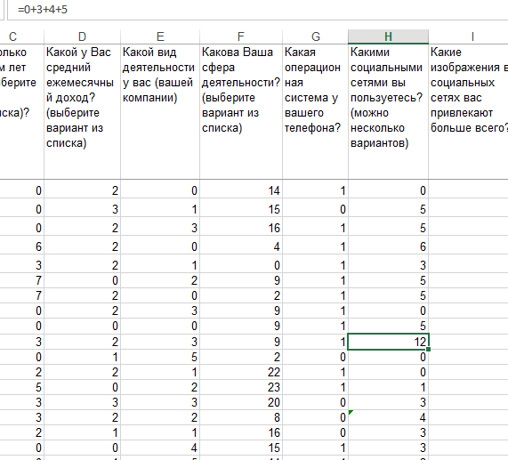

Figure 4 – Collective dummy variable values for multiple option questions

In order to build a regression model, we transformed all qualitative values into quantitative values and prepared the table for the model building. We checked for empty spaces and eliminated all possible mistakes. We also made sure that all dummy variables from the legend table matched the Data Set values accurately.

As a result, we obtained our Transformed Data Set (Figure 5), which full version can be found in Table 3 of Appendix 1.

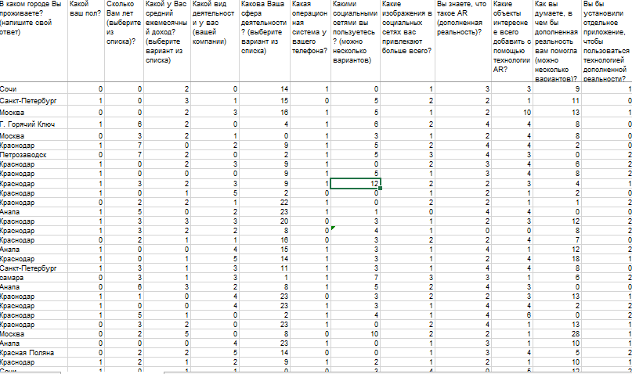

Figure 5 – Transformed Data Set (Sample)

3.3 Forecasting of the future impact of Augmented Reality efficiency as a marketing tool.

In this part of our paper, we carried out the regression model and further forecasting of the AR as a marketing tool. The purpose was to analyse the responses and see how the general awareness of the Russian population about the AR correlates with their willingness to buy the AR products in the future.

If we take all values except for location and willingness to buy the application as X-variables and the last response as the Y-variable, we get the following regression model (Figure 6).

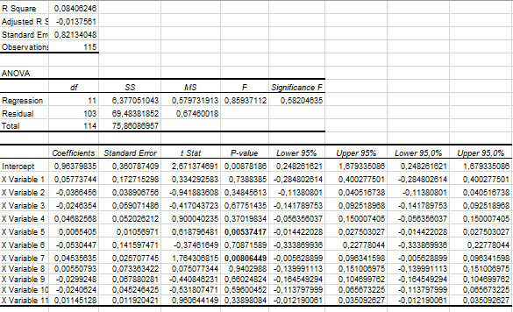

Figure 6 – the Multiple Regression Model with all variables

Based on this data we can see that our *P*-values have significant variance between variables. *P-*value for the X variable 5 is 0.00537417 and X variable 7 is 0,00806, which is the smallest P-value and is under 0.05 while P-value­of the rest variables are significantly more than 0.05. Thus, we can see that inclusion of most variable is not needed in this model and may even prove to be detrimental.

This test shows that using MLRM is not always necessary and using a simpler LRM may suffice. Therefore, we built a model again, with only 2 variables (X5 and X7), the result was the following (Figure 7). The model shows that the P-value of Variable 7 (2) here is the only suitable option. Therefore, the number of social networks people use affects their willingness to install an AR application on their phone.

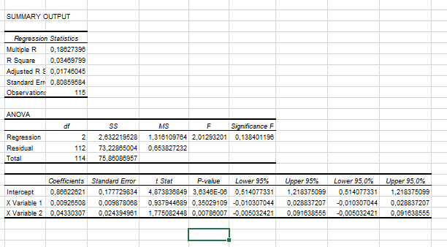

Figure 7 – MLRM with 2 X Variables

CONCLUSION

In Chapter 1 we have covered the main definitions and terms of the Multiple Regression analysis. We also observed the main principles of econometrics and its goals. We listed different types of models and data. We described the errors, which can be made during the econometric analysis and grouped them by types. We systematized various types of variables that can be used in an econometric model.

We dealt with Multiple Regression Model and Analysis and covered the main principles of its construction. We observed and described the OLS method and also explained the possible downsides of multicollinearity.

Based on the fundamental works of acclaimed researchers, we gave an outline of efficient variable choice and methodology of the econometric model building.

In Chapter 2 we focused on the role of AR in today’s world. We gave definition to Digital Marketing and its role in today’s economy. We observed and explained the principle of developing AR and VR technologies and described global forecasts about them. We also listed various factors that influence the AR development nowadays. Then we gave numerous examples on AR efficiency as a marketing tool and possible use of the technology in the economy.

Chapter 3 was dedicated to the econometric modelling of the AR popularity in Russia. We carried out a questionnaire and gathered qualitative data for our model. Then we assigned a numerical value to each position and transformed the data set, in order to make it suitable for regression. We made the regression model and chose two variables that correlated most. As a result, we stated that the use of social media has a high effect on AR awareness.

However, the research has also shown that the overall popularity of AR on the Russian marked is far beyond the International and Western level. The population is not yet aware or familiar with the technology, so we can say that the Russian market is not yet ready for AR mass production.

List of Literature

1. Admonitoring.group. Burger King | AI created | Chicken Sandwich Crossing Encouraged, 2018.

https://www.youtube.com/watch?v=OtCI5xiUXTY&feature=youtu.be

1. Anderson David R., Sweeney Dennis J. Essentials of Statistics for Business and Economics, 7th Edition, 2015. Print ISBN: 9781133629658.
2. Burberry Press Release. Limited Edition Pieces From Riccardo Tisci's First Burberry Collection To Be Made Available Through A Series Of 24-Hour Product Releases. 10 Sep 2018. https://www.burberryplc.com/en/news-and-media/press-releases/corporate/2018/limited-edition-pieces-from-riccardo-tisci-s-first-burberry-coll.html
3. Chaffey D., Ellis-Chadwick F. Digital Marketing: Strategy, Implementation and Practice. Harlow: Pearson Education, 2012. ISBN 0273746227.
4. Chaffey, D. Internet Marketing, 4th edition, Pearson Education, 2009.
5. Greene William H. Econometric Analysis, 8th Edition, Stern School of Business, Pearson, New York Universit, 2018.
6. Hadri K., Mikhail W. Econometric Methods and their Applications in Finance, Macro and Related Fields. London: World Scientific, 2014.
7. Heij C. Econometric Methods with Applications in Business and Economics, Erasmus University in Rotterdam, OUP Oxford, Mar 25, 2015.
8. Johnston J., DiNardo John Enrico, Econometric Methods, McGraw-Hill, 1997.
9. Kaiser R., Schatsky *D.* For more companies, new ways of seeing. Momentum is building for augmented and virtual reality in the enterprise, Deloitte University Press, 2017.
10. Kierzkowski, A., McQuade S., Waitman R., Zeisser M. Marketing to the digital consumer, The McKinsey quarterly , Vol. 3, 1996.
11. Kotler P. Marketing 4.0: Moving from Traditional to Digital, ISBN: 978-1-119-34120-8, December 2016.
12. Kunkel N., Soechtig S., Miniman J., Tech Trends 2016: Augmented and virtual reality go to work, Deloitte University Press, February 24, 2016.
13. Live Animations Corp. Cartoon Ice cream My Yeti in Augmented reality (AR), 2017. https://www.youtube.com/watch?v=9fXNrbeFkcc
14. Market and Markets. Augmented Reality and Virtual Reality Market by Offering (Hardware & Software), Device Type (HMD, HUD, Handheld Device, Gesture Tracking), Application (Enterprise, Consumer, Commercial, Healthcare, Automotive), and Geography – Global Forecast to 2023 (2018) https://www.marketsandmarkets.com/ (Retrieved 15.01.2019).
15. Mashable. New Balance Used AI to Spot Trendsetters During Fashion Week - Did We Make the Cut? 2018. https://www.youtube.com/watch?v=zZ2iWK6eL5k&feature=youtu.be
16. McEleny Charlotte. Ikea uses programmatic to drive footfall by changing Indonesia's perception of traffic. 27 August 2018. https://www.thedrum.com/news/2018/08/27/ikea-uses-programmatic-drive-footfall-changing-indonesias-perception-traffic
17. Merel T. The reality of VR/AR growth, TechCrunch, January 11, 2017.
18. Merryll Lynch, Bank of America, Future Reality: Virtual, Augmented & Mixed Reality (VR, AR & MR) Primer (2016) https://www.bofaml.com/content/dam/boamlimages/documents/articles/ID16_1099/virtual_reality_primer_short.pdf.
19. Miller M. Online Marketing Heroes, Wiley, 2008.
20. Montgomery Douglas C. Introduction to Linear Regression Analysis, 5th Edition, ISBN: 978-0-470-54281-1 April 2012.
21. Old Spice. Get Ready For The Old Spice Foam Zone | Old Spice. 2018. https://youtu.be/B_bqTqt_KM0
22. Olive David J. Linear Regression, Springer, Apr 18, 2017.
23. PromoMarketing. Yorkshire tea launches AR experience to teach environmental sustainability, 2018.
24. Recombu. OnePlus Crackables Hands-on | Solve puzzles, win cash! 2018. https://youtu.be/dd5VvKXfwac
25. Ryan, D. Understanding Digital Marketing: Marketing Strategies for Engaging the Digital Generation Ed. 3. 1st ed. Kogan Page, 2014.
26. Verbeek M. A Guide to Modern Econometrics, John Wiley & Sons, May 27, 2008.
27. Weisberg S. Applied Linear Regression, John Wiley & Sons, Nov 25, 2013.
28. Wooldridge Jeffrey M. Econometric Analysis of Cross Section and Panel Data, MIT Press, 2010.

APPENDIX 1

Table 1 – Initial Data set



Continuation of the table



Continuation of the table



Table 2 – Dummy variables for the Data set (Notations)

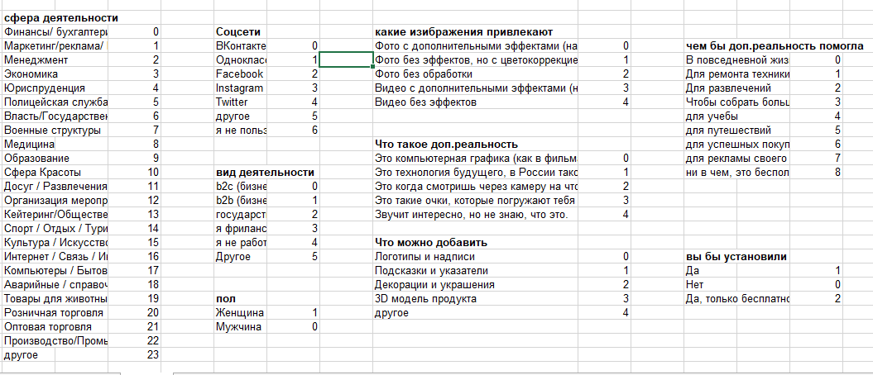

Table 3 – Transformed Data Set



Continuation of the table

